Royal Sigdel

21175837

Assignment on

CLoud Computing using AWS

Table of Contents

LIST OF FIGURES: 2

Introduction 3

Risk evaluation for cloud solutions: 3

Running the Business: 4

Cloud Services: 5

Estimated Cost: 5

Implementation: 6

User’s accounts, Policies, Security Credential and Permission: 6

VPC Creation and Lunch: 8

Instance Type Upgrade: 13

Storage Expand: 15

Database: 18

Auto Scaling and Load Balance: 19

# LIST OF FIGURES:

Figure 1 Error in user group creation 6

Figure 2 Error in user creation 7

Figure 3 Business Admin Policy 7

Figure 4 VPC creation 9

Figure 5 Private Subnet 9

Figure 6 Public Subnet 10

Figure 7 Internet Gateway 10

Figure 8 NAT Gateway 11

Figure 9 Route Table 11

Figure 10 Web Security Group 12

Figure 11 EC2 Instance 12

Figure 12 Lunching Web Server 13

Figure 13Instance type change 13

Figure 14 Log of Instance Part 1 14

Figure 15 Log if Instance Part 2 14

Figure 16 New Volume Creation 16

Figure 17 Snapshot Creation 17

Figure 18 File System Configuration 17

Figure 19 File System Configuration 18

Figure 20 AMI for instance 19

Figure 21 Register Targets for instance. 19

Figure 22 Target Groups 20

Figure 23 Error while creating Load Balancer 20

Figure 24 Missing Load Balancer Configuration menu in Auto Scaling 21

# Introduction

It is simple for individuals and organizations to develop, distribute, and manage applications and services thanks to AWS (Amazon Web Services), which offers a wide range of cloud computing services. It offers a wide range of platform services, software services, and infrastructure services, so there is no need for upfront investments in hardware or infrastructure.

# Risk evaluation for cloud solutions:

When performing a risk analysis for a cloud solution, there are several factors to consider. A cloud solution offers the advantages listed below, which are frequently emphasized:

1. Data security: To ensure network security, encryption, and access controls, cloud service providers like AWS invest heavily in robust security measures. They offer better security than many internal infrastructures because they make use of specialized security teams to monitor threats and lessen them.

2. Disaster Recovery and Business Continuity: Cloud services offer built-in redundancy and high availability through a number of data centers around the world. This lessens the likelihood of downtime and ensures that operations will continue in the event of emergencies.

3. Scalability and Elasticity: Cloud infrastructure enables businesses to scale resources up or down in response to demand, which offers flexibility, cost savings, and improved performance.

4. Cost Optimisation: By only paying for the resources they actually use, pay-as-you-go pricing models made available by cloud services allow businesses to cut expenditures. It eliminates the need for sizable upfront capital investments while improving cost control and optimisation.

5. Technical Support and Expertise: Cloud service providers give consumers access to skilled specialists and guarantee dependable and efficient solutions. They also offer broad technical support and expertise.

6. Geographic Redundancy: Cloud service providers offer geographic redundancy and reduce the chance of data loss or service disruption by running data centres in several regions.

7. Compliance and Regulatory Requirements: Cloud service providers adhere to certifications and regulatory standards pertaining to their industry, making it simpler for enterprises to follow the law.

# Running the Business:

Our company depends on using the numerous services and capabilities that AWS provides and hosting our web server on its cloud platform. As a result, we can align the AWS Cloud's capabilities with our company's ideals.

Arguments in favour of the cloud over internal infrastructure. The decision to choose cloud infrastructure over internal infrastructure is supported by the following factors:

1. Scalability: Cloud architecture enables quick and efficient resource scaling in response to demand, which reduces costs and improves performance.

2. Cost-effectiveness: Cloud infrastructure decreases initial capital investment by doing away with the need for physical hardware. By only paying for the resources they utilise, organisations enhance cost control and optimisation.

3. Dependability and Availability: Cloud service providers, like AWS, operate a large number of data centres all over the world, offering built-in redundancy and high availability. This ensures minimal downtime and reduces the possibility of service interruptions.

4. Security: Cloud service providers employ a range of security measures, including encryption, network security, and access controls. In comparison to internal infrastructures, they have specialised security teams that provide superior defence.

5. Global Reach: Cloud infrastructure helps businesses to reach a global audience by delivering apps closer to end users, reducing latency, and improving user experience.

6. Focus on Core Competencies: By depending on cloud infrastructure, businesses may outsource infrastructure management and hardware maintenance, allowing them to focus on their Core Competencies and Strategic Objectives.

7. Cloud infrastructure allows faster time-to-market while simultaneously enabling agility and innovation. It enables speedy resource deployment, supports continuous integration and deployment, and promotes the use of cutting-edge technologies and architectural designs.

# Cloud Services:

we are using the AWS cloud services listed below and maximising their capabilities:

1. Amazon EC2 (Elastic Compute Cloud): To host virtual servers for the web server application, EC2 instances are deployed.

2. Archiving static assets delivered by web servers, such as images, CSS, and JavaScript, using Amazon S3(Simple Storage Service).

3. Setting up and maintaining a relational database (like MySQL or PostgreSQL) for the web application's data storage using Amazon RDS (Relational Database Service).

4. Amazon Route 53: Managing DNS so that people can reach the web server by typing in a domain name.

5. Amazon CloudWatch: Monitoring the web server's functionality, state, and resource utilisation, giving crucial data for troubleshooting and optimisation.

6. Amazon VPC (Virtual Private Cloud): Enhances security and administrative capabilities while giving the web server a virtual network environment.

# Estimated Cost:

The cost of running a web server on AWS depends on a variety of factors, including instance types, storage needs, database size, data transit, and geographic region. Pricing options like on-demand instances, reserved instances, or spot instances have an impact on the overall cost as well. For a precise cost estimate, it is advisable to use the AWS Pricing Calculator or consult with AWS specialists. These specialists can evaluate the specific requirements of the web server and provide a comprehensive cost analysis.

Hosting a basic web server on AWS is projected to cost between $10 and $100 per month, depending on the precise requirements and usage patterns.

Please be mindful that these costs are simply estimates and could change based on the location, instance type, usage trends, and any cost-cutting measures implemented (such, for instance, employing reserved instances). For a more precise cost estimate that is tailored to your unique needs, use the AWS Pricing Calculator or talk to AWS professionals.

# Implementation:

## User’s accounts, Policies, Security Credential and Permission:

I couldn’t create any groups and users in AWS Learners Lab. Following error was displayed while creating users and groups:

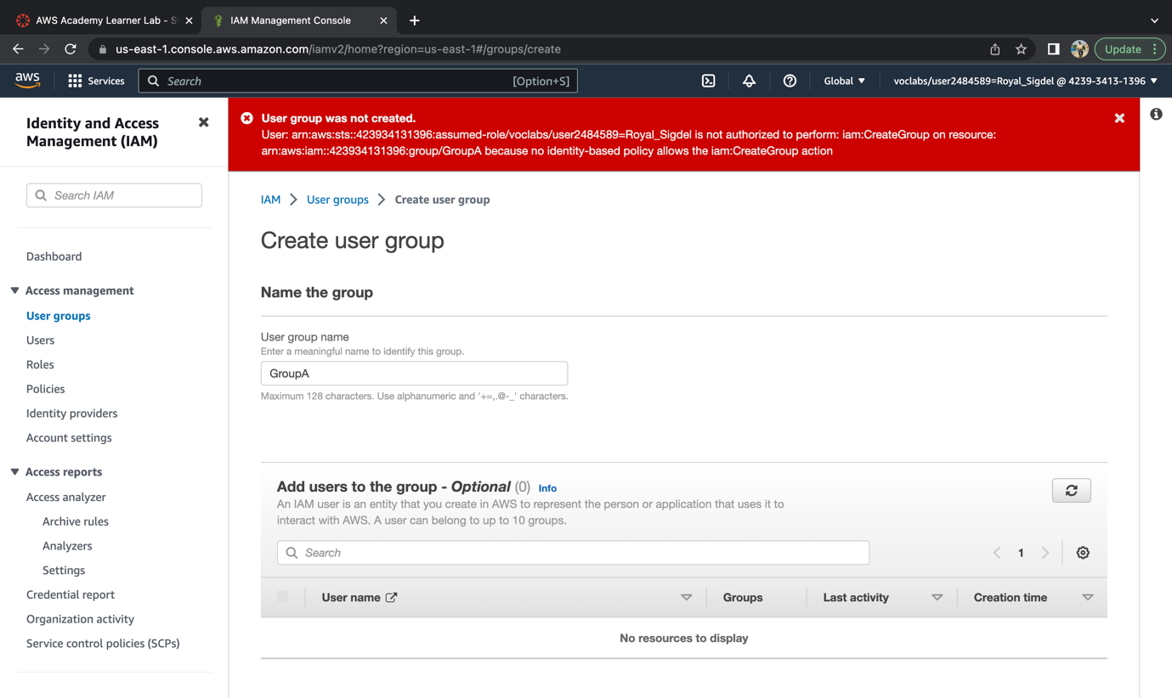

Figure 1 Error in user group creation

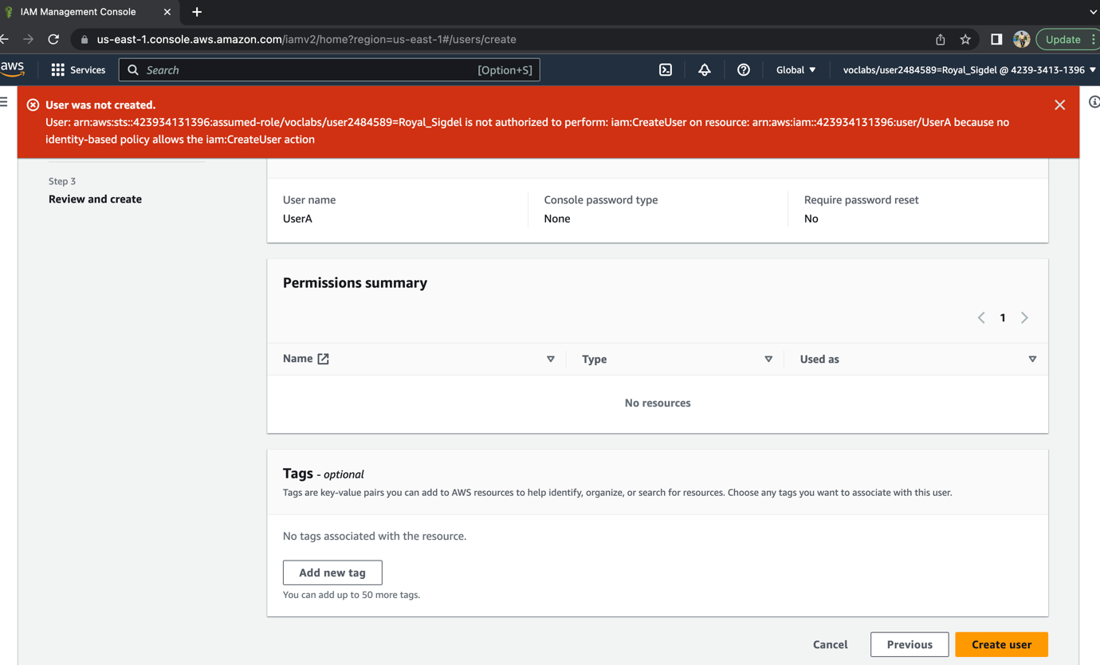

Figure 2 Error in user creation

I was able to create the policy which is done as in below screenshot:

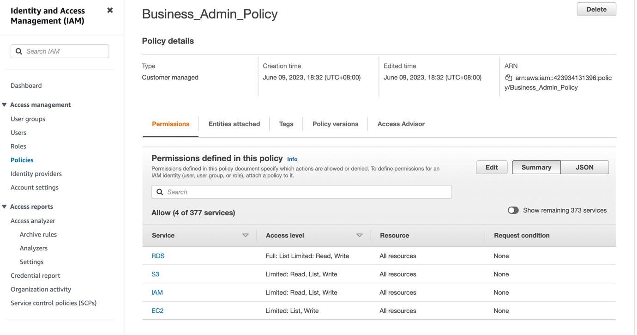

Figure 3 Business Admin Policy

## VPC Creation and Lunch:

The objective of Task was to create Virtual Private Cloud (VPC) in AWS and learn how to create a custom VPC, subnet, internet gateway, security group, and launch a web server in the VPC.

I created a new VPC with a CIDR block range, and then dividing it into two subnets. Each subnet was assigned a different CIDR block range. The next step was to create an internet gateway and attach it to the VPC in order to enable internet access. This was a vital step in the process, as it allowed the VPC to communicate with other networks and the Internet. All these steps were necessary in order to complete the lab and ensure a properly configured network.

In the next step, the attendees were shown how to create a security group and configure the inbound and outbound rules to allow access to the web server. I created an Amazon Elastic Compute Cloud (EC2) instance and launch it in one of the subnets, as well as assigned a public IP address to the instance for external access. This was done in order to allow for secure remote access to the web server. After the security group was created and configured, Then I connected to the EC2 instance using the PuTTY SSH client. Finally, tested the connection to the web server by accessing a web page hosted in the EC2 instance.

Following are the screen shot of VPC , Subnet, Internet Gateway, NAT Gateway and Route Table:

Figure 4 VPC creation

Figure 5 Private Subnet

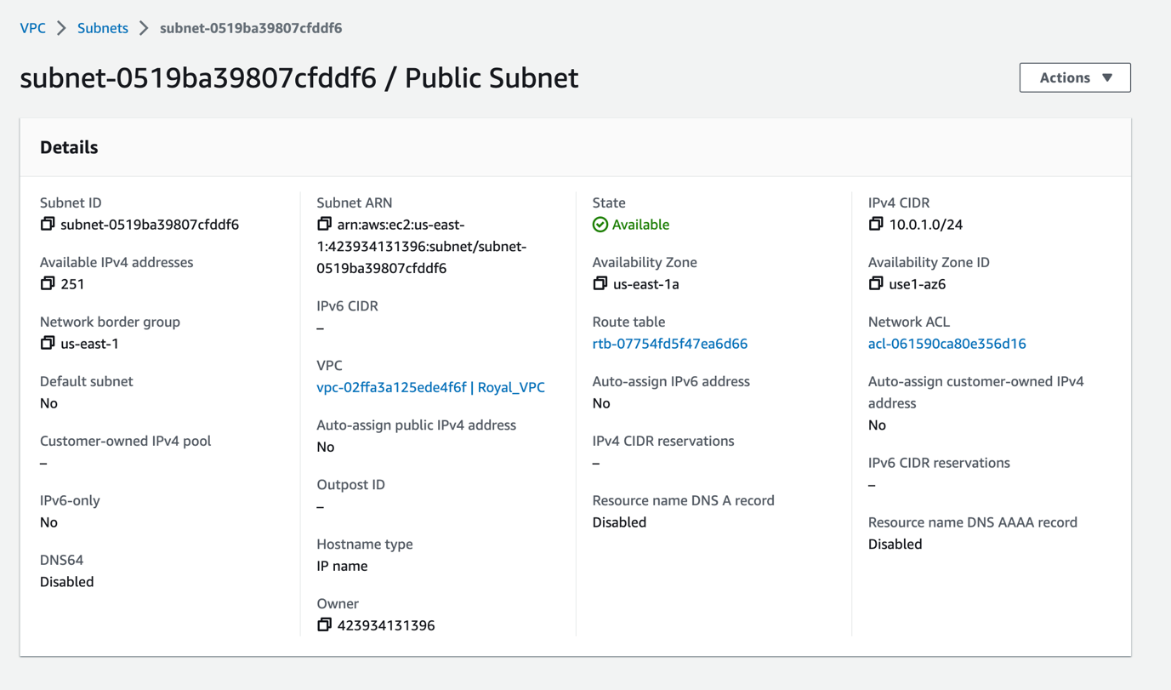

Figure 6 Public Subnet

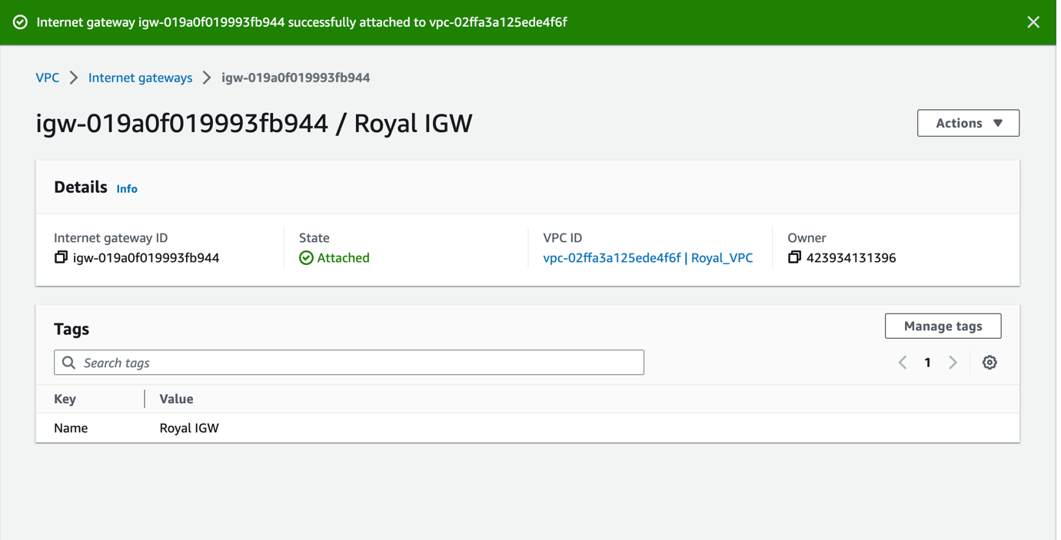

Figure 7 Internet Gateway

Figure 8 NAT Gateway

Figure 9 Route Table

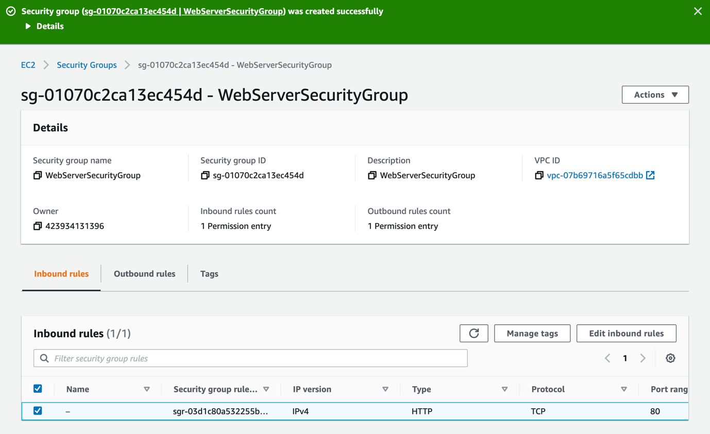

Figure 10 Web Security Group

Figure 11 EC2 Instance

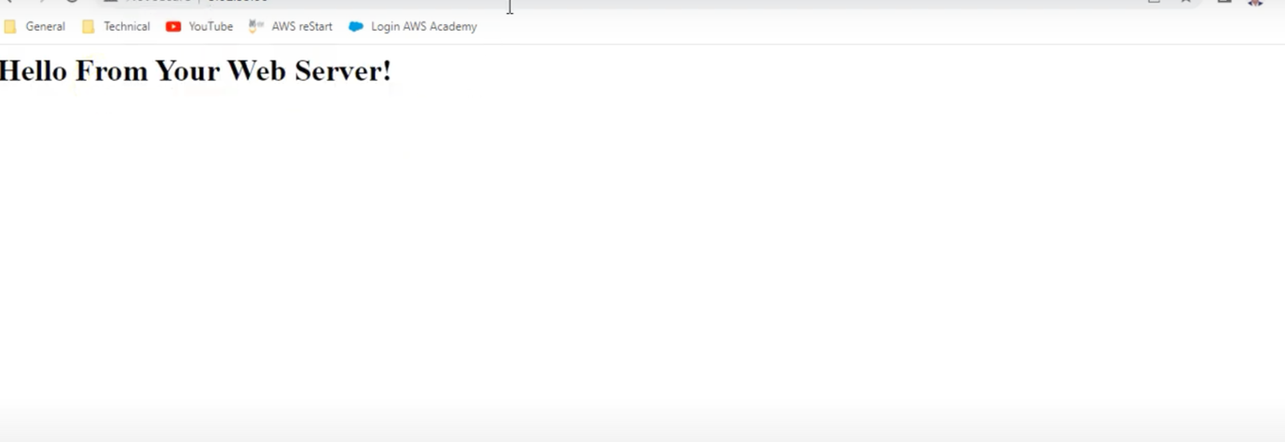

Figure 12 Lunching Web Server

## Instance Type Upgrade:

The instance type of the instance “My Web Server” is changed to t2.medium and the log is captured and shown in below screenshots:

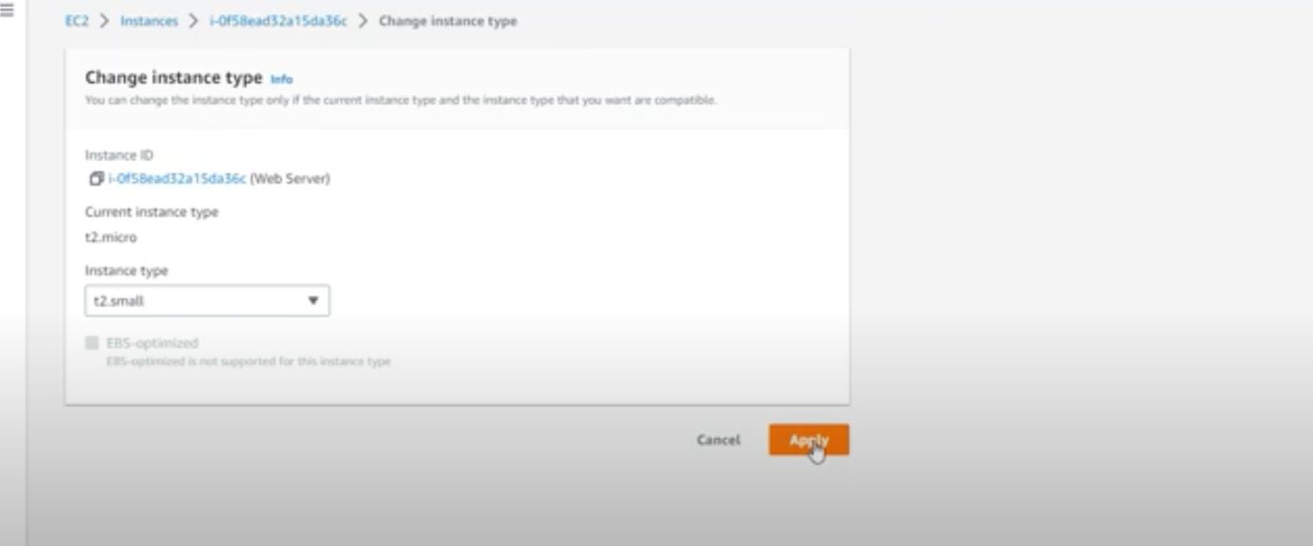

Figure 13Instance type change

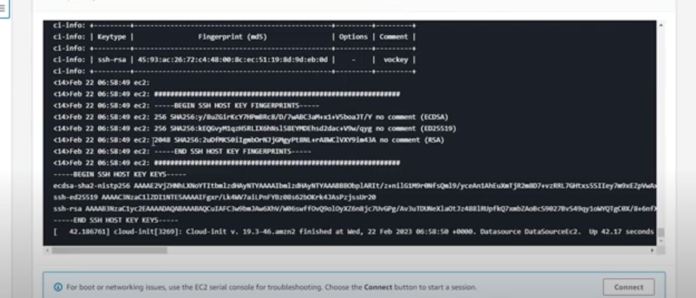

Figure 14 Log of Instance Part 1

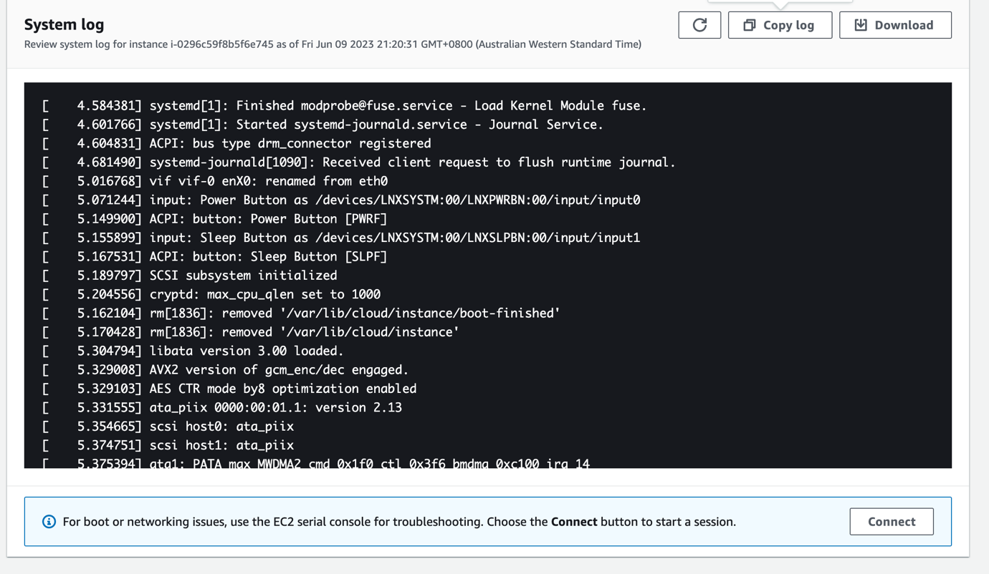

Figure 15 Log if Instance Part 2

## Storage Expand:

The first step was to select the EC2 instance that was most suitable for the task. I had to create the new EBS volume from the volumes tab considering volume type as general-purpose SSD (gp2), size (GiB) as 1, availability zone same as in instance and adding tag along with Key as Name and Value as My Volume. After creating the volume, I was ready for attaching the volume to instance.

The next step was to attach the newly created volume to instance. In the volume tab, newly created volume named as My Volume was available. I had to attach the instance from the action button by choosing the appropriate instance. Once the volume is attached, I had to connect to Amazon EC2 instance by using SSH command. I had to download the “labsuser.pem” file and run the below command to connect to EC2 instance:

* chmod 400 labsuser.pem
* ssh -i labsuser.pem ec2-user@3.234.223.63

The next step was to create the ext3 file system and add directory in it to mount the new volume. Following commands were used to create file system, directory, file and mount the new volumne:

* sudo mkfs -t ext3 /dev/sdf
* sudo mkdir /mnt/data-store
* sudo mount /dev/sdf /mnt/data-store
* echo "/dev/sdf   /mnt/data-store ext3 defaults,noatime 1 2" | sudo tee -a /etc/fstab
* cat /etc/fstab
* df -h
* sudo sh -c "echo some text has been written > /mnt/data-store/file.txt"
* cat /mnt/data-store/file.txt

Furthermore, the next step was to create snapshot. I had to create snapshot from the new volume named My Volume. I was able to create snapshot by selecting create snapshot from the action dropdown button by adding tag key as Name and value as My Snapshot. I had to remove the file by using command “sudo rm /mnt/data-store/file.txt” and then I had to create volume from the snapshot. I had to select My Snapshot and then I had to select create volume from snapshot which was a dropdown option of action button.

Finally, the volume created from snapshot is attached to the appropriate instance and mounted the restored volume by following command:

* sudo mkdir /mnt/data-store2
* sudo mount /dev/sdg /mnt/data-store2

Figure 16 New Volume Creation

Figure 17 Snapshot Creation

Figure 18 File System Configuration

## Database:

I tried to create the relational database instance was created by selecting MySQL as engine, Dev/test as templates, Multi AZ DB instance, Burstable classes, general purpose SSD as storage type, lab VPC, DB security groups and so on but system displayed the permission issue which is attached in the screenshot below:

Figure 19 File System Configuration

## Auto Scaling and Load Balance:

I was able to create AMI, Register Targets, Target Groups but I was not able to do the load balancing. I couldn’t automate load balancer as Load Balancing Configuration option was missing which is shown in the attached screenshot:

Figure 20 AMI for instance

Figure 21 Register Targets for instance.

Figure 22 Target Groups

Figure 23 Error while creating Load Balancer

Figure 24 Missing Load Balancer Configuration menu in Auto Scaling